**Experiment No. 2(A) Objective:** Write simple fact for the following:   
a. Ram likes mango.

b. Seema is a girl.

c. Bill likes Cindy.

d. Rose is red.

e. John owns gold.

**APPARATUS USED:** SWI-PROLOG 9.0.4

**Program:**   
In Prolog, the format for expressing facts is generally predicate(term1, term2,..., termN).

where predicate is the name of the relation, and term1, term2, involved in the relation. Each term can be a variable, an atom, or a compound term.

**CODE:**   
Create a file 'facts.pl' and write the following facts in it:

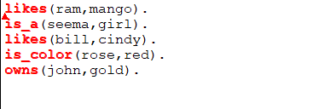

Now open SWI-Prolog and consult 'facts.pl' and type in your queries.

**OUTPUT:**

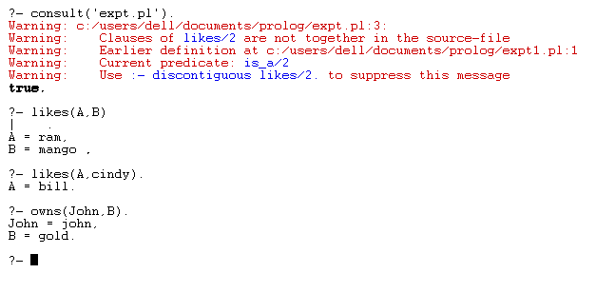

**Outcome:** Student will understand how to write simple facts using prolog.

**Experiment No. 2(B)**

**Objective:** Write simple fact for the following:

Sachin likes cricket   
Saurav likes cricket   
Raj likes Football   
Karan likes Basketball   
Indira likes Chess   
Parth likes whatever Saurav likes

Also write code for following Queries:

Display list of all player with games they like   
Find name of all player who like cricket   
Check whether Raj likes cricket or not  
Display names of player who like any game except cricket

**APPARATUS USED:** SWI-PROLOG 9.0.4

**CODE:**

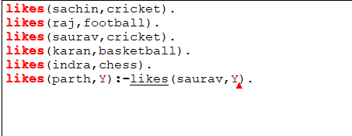

**OUTPUT:**

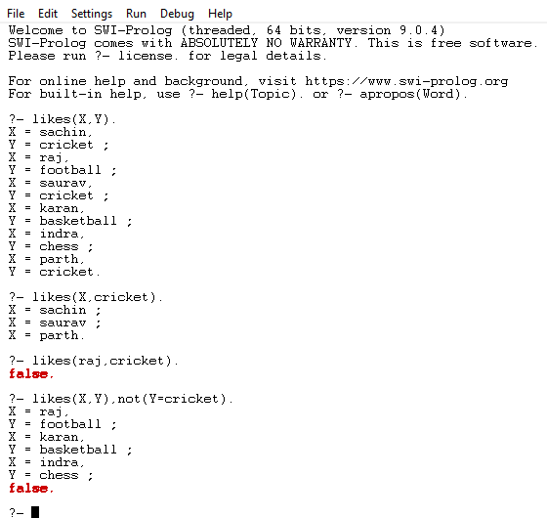

**Outcome:** Student will understand how to write simple facts using prolog.